Moles Galore: Quantitative Chemistry

Goals
- Establish a solid understanding of moles and Avogadro’s number
- Practice estimation skills
- Introduction to common ions used in chemical reactions
- Have fun and get to know your fellow students

Background
- Atoms, molecules, and ions: The atom is the smallest unit that can be identified as a specific element (e.g. a copper atom, containing one copper nucleus surrounded by electrons). Molecules contain many atoms bonded together. Ions are charge species, and can be either atoms or molecules.
- The mole is a unit that helps us answer the question "How much?" It makes numbers much more manageable. Just like donuts are measured in dozens, and paper is measured in reams, atoms and molecules are measured in moles. Mole is abbreviated "mol".
- Avogadro's number: N_{A}= 6.022142 x 10²³ mole⁻¹ refers to the number of items in a collection containing 1 mole of that item. It is derived from the number of atoms in exactly 12 grams of carbon-12 (e.g. a 60-carat diamond, or a 1.8 cm cube of graphite). For some interesting history and controversy regarding Avogadro's Number, read An Exact Value for Avogadro's Number.
- The mole in reactions:
The mole is the common language in a chemical reaction. For example, for the reaction:
Pb⁺²_{(aq)} + 2OH¯_{(aq)} → Pb(OH)_{2(s)}
You could say:
1 Pb⁺² ion reacts with 2 OH¯ ions to form 1 lead(II) hydroxide molecule, or
1 mole of Pb⁺² reacts with 2 moles of OH¯ to form 1 mole of lead(II) hydroxide
However:
1 gram of Pb⁺² and 2 grams of OH¯ do NOT form 1 gram of lead(II) hydroxide
- Atomic/molar mass: Each cell in the periodic table contains a non-integer number. This represents the average mass of one atom of this element (in amu). It also represents the mass of one mole of an average sample of this element (a.k.a. "molar mass", in grams/mole). The molar mass of a compound is the sum of the molar masses of each atom in the compound.
- Converting grams to moles:
Use dimensional analysis (i.e. set up the problem using just units):
grams * (moles/gram) = moles
grams / (grams/mole) = grams / (molar mass) = moles
- Converting molarity to moles for solutions:
The unit M = moles/liter is used to refer to the concentration, or "molarity" or a solution. To convert from molarity to moles, you must know concentration and volume of a solution. Use dimensional analysis (i.e. set up the problem using just units):
L * (moles/L) = moles
For future reference, here is a chart of some of the most popular ions that are seen in aqueous chemical reactions:
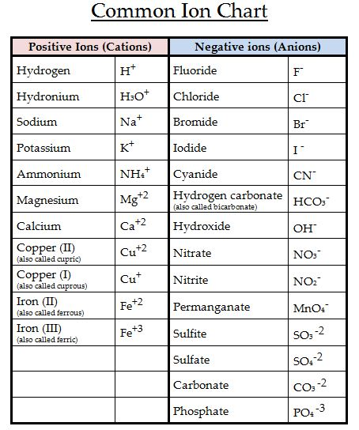
Here is a pdf of the chart above.
We will be refering to these ions throughout the semester, so please download the chart and make it easily accessible to you.

Synopsis of the Experiment
In this experiment, you will observe the reaction of iron nails (Fe_{(s)}) with a solution of copper(II)sulfate (CuSO_{4(aq)}, which dissociates in water to form Cu⁺²_{(aq)} and SO₄⁻²_{(aq)}). The iron and copper react to form iron ions in solution (Fe⁺²_{(aq)} or Fe⁺³_{(aq)} - you will determine which one) and solid copper (Cu_{(s)}). You will determine the number of moles involved in the reaction.
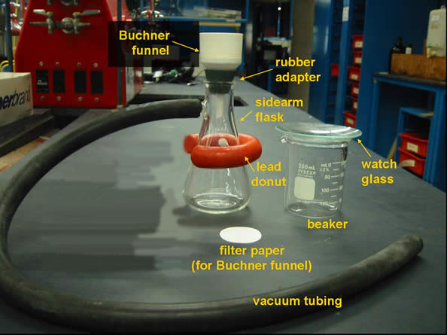
Figure 1 - Glassware and Vacuum Filtration Setup (you will not need watch glass)

Experiment
To print instructions, select the portion that you wish to print, choose File/Print, and choose "selection" to prevent printing the entire web page.

Safety
**1 M HCl and 0.500M copper(II)sulfate solutions are skin and eye irritants.If any of the solutions above come in contact with your skin or eyes, please rinse affected area with copious amounts of water.
[ Please neutralize any hydrochloric acid spills with saturated sodium hydrogen carbonate solution.]
**In Workshop 1, solid caffeine is toxic and an irritant.
Avoid contact with skin, eyes, and clothing.
- Wear safety glasses, lab coats and nitrile gloves.
- Place all waste solutions and solids in the waste containers provided.
- Clean up after yourselves:
  - Rinsed beakers and graduated cylinders go in the big orange bin by the door.
  - Disposable pipettes go in the glass disposal boxes.
  - Disposable pipette bulbs are not disposable and go back where you got them.
  - Everything else gets rinsed and put back where you got it.

Materials and Equipment
- 0.500 M copper(II)sulfate (note exact concentration given on bottle, including correct number of significant figures)
- 2 iron nails (six penny size)
- 1M hydrochloric acid
- beakers (250 mL)
- wash bottle
- tongs
- stirring rod
- sandpaper
- top loading balance
- 42.5 mm Filter paper
- Buchner funnels
- Filter flasks
- Filter adapters

Instructions
During today's lab, you will perform the reactions below. There will be a waiting period, during which you will do Workshop 1. Then you will complete the experiment.
Students will work in groups of 2-4.
- Using a graduated cylinder, add 50.0 mL of the 0.500 M CuSO₄ solution to a 250 mL beaker
- Obtain two clean, dry nails. If the nails are not clean, use a piece of sandpaper to make the surface of the nail shiny. Record the mass of the cleaned nails to the nearest 0.01 g
- Place the nails into the beaker with the 0.500 M CuSO₄ solution. Record the start time and let the reaction proceed for at least 1 hour, swirling every 5-10 minutes to displace any copper that has plated out on the iron. If, at any time, the nails seem to be coated with copper so that the solution cannot access the iron in the nails, scrape them a little with a spatula. During this time, record your observations periodically and perform Workshop 1.
- Note the reaction's ending time. Your lab instructor will let you know when to stop the reaction with enough time left to complete the experiment.
- Using gloves, pick up the nails, one at a time. With a spatula, scrape any excess copper from the nails back into the beaker. Without disturbing the copper already in the beaker, swirl the spatula and scraped nails in the liquid remaining in the beaker to rinse off any remaining copper. Set the scraped nails onto a paper towel.
- After the nails are completely dry, find the mass of the nails and record it in your data table.
- Obtain a piece of filter paper and place it into a Buchner funnel. Add a label to the funnel's sides with your name. Record the combined weight of the funnel top and filter paper.
- Place the filter assembly into a filter flask that will serve to collect the liquid (see Figure 1). Wet the filter paper with deionized water and apply the vaccum. After turning on the vacuum, pour the contents of the beaker (including solid) onto the filter paper, rinsing the beaker with deionized water as necessary to remove all solid from the beaker.
- Next, rinse the solid in the filter assembly with ~ 25 mL of 1M hydrochloric acid followed by ~ 25 mL water and then ~ 25 mL acetone.
- Leave the copper in the filter apparatus with the vacuum on for an additional 15 minutes.
- Once the copper and filter paper are completely dry, find the combined mass of the copper and funnel top. Then determine the mass of the formed Cu solid using the difference in recorded masses.
Data Table I
Weighed items | Mass to nearest .01 grams  Before reaction begins | Mass to nearest .01 grams  After 2 hours of reaction
two nails
Iron solid  consumed | __________
Funnel +  Filter paper |  | Dried with Cu solid:
Copper solid formed | __________
Time | Start: | End:
Observations:

Disposal
Put all liquid chemical waste in the big waste container provided. This includes the liquid in your filter flask. Put solid waste (i.e. copper and iron and filter paper) in the jar for solid waste. Rinsed beakers and graduated cylinders can go in the big orange bin by the door. Disposable pipettes go in the glass disposal boxes. Bulbs for disposable pipettes are not disposable, and go back where you got them. Everything else gets rinsed and put back where it came from.

Understanding the Reaction
This section does not need to be performed during lab.
CuSO₄ dissociates in water to form the ions Cu⁺²_{(aq)} and SO₄⁻²_{(aq)}. The copper reacts with the iron nails in solution to form iron ions in solution (Fe⁺²_{(aq)} or Fe⁺³_{(aq)} - you will determine which one) and solid copper (Cu_{(s)}). Look up the definition of a spectator ion and explain why SO₄⁻² qualifies.
The reaction is called a redox reaction, meaning that electrons are exchanged between the copper and iron. The copper(II) ion (Cu⁺²_{(aq)}) will undergo reduction (gain of electrons). Meanwhile, the iron (Fe_{(s)}) will undergo oxidation (loss of electrons). Each iron atom will lose the same number of electrons that a copper atom gains. The overall reaction can be divided into two half-reactions as follows:
- The Reduction reaction:
The chemical species that undergoes reduction gains electrons. Cu⁺² gains two electrons to produce the uncharged solid, Cu:
Cu⁺²_{(aq)} + 2 electrons → Cu_{(s)}
- The Oxidation Reaction
The chemical species that undergoes oxidation loses electrons. Iron solid can lose wither two electrons for form Fe⁺² or it can lose 3 electrons to form Fe⁺³:
Fe_{(s)} → Fe⁺²_{(aq)} + 2 electrons or Fe_{(s)} → Fe⁺³_{(aq)} + 3 electrons
- The Overall Balanced Reaction (showing an equivalent number of exchanged electrons)
In order obtain an equivalent number of exchanged electrons in an overall balanced reaction, a half reaction must often be multiplied by a coefficient. The table below shows how to determine the overall balanced reaction for each possible iron product. First, look at the first column. The number of electrons used is already the same as the number of electrons produced, so the reaction equations do not need to be multiplied by coefficients. Combine the two half reactions to give your overall balanced reaction. Similarly, fill in the blanks in the second column:
A. If Fe⁺² is the product | B. If Fe⁺³ is the product
Reduction:  Cu⁺²_{(aq)} + 2 e¯ → Cu_{(s)} | Reduction:  3 x [Cu⁺²_{(aq)} + 2 e¯ → Cu_{(s)}]
Oxidation:  Fe_{(s)} → Fe⁺²_{(aq)} + 2 e¯ | Oxidation:  2 x [Fe_{(s)} → Fe⁺³_{(aq)} + 3 e¯]
Overall balanced reaction:  Cu⁺²_{(aq)} + Fe_{(s)} → Fe⁺²_{(aq)} + Cu_{(s)} | Overall balanced reaction:  3 Cu⁺²_{(aq)} + 2 Fe_{(s)} → 2 Fe⁺³_{(aq)} + 3 Cu_{(s)}
Note that the number of electrons in the overall balanced reaction cancel, as an equal number are present on both sides.
Your experimental data will tell you which iron ion is the final product because you can calculate the molar ratio of Cu(s) formed : Fe(s) consumed.

